Instruction Guide

**\*DISCLAIMER: NOT RESPONSIBLE FOR INJURIES OR DAMAGE\***

**Items Needed:**

1. Raspberry Pi
2. SD Card
3. SD Card slot or reader
4. SD Card writer
5. Power supply for Raspberry Pi
6. GPIO wires
7. AC to DC convertor
8. Internet Access **even after power loss**
9. Power for Raspberry Pi in the event of power loss

**Explanation:**

**\*Please read, as working with power lines is extremely dangerous\***

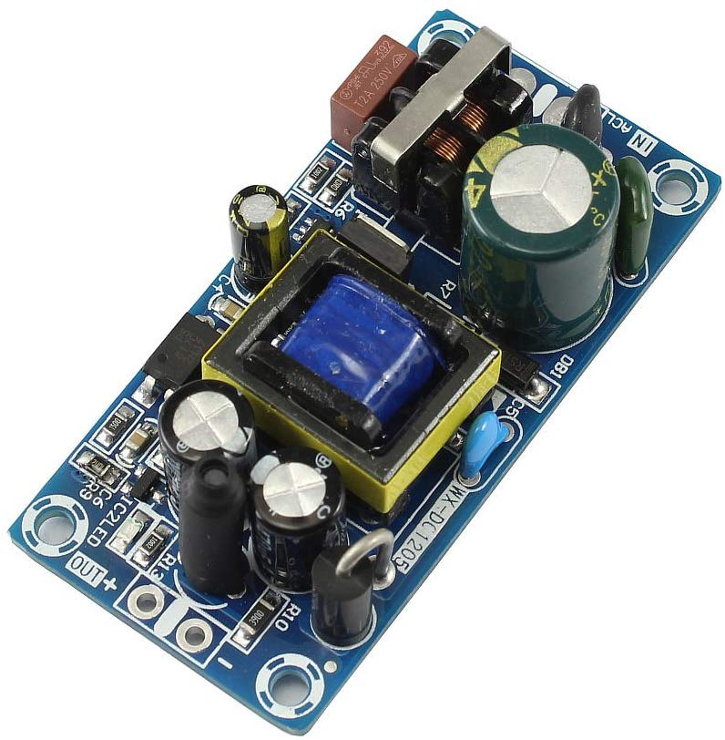

Above is an AC to DC convertor. To monitor GPIO pins, a 3.3 or 5V line is needed. Straight line voltage should **not** be used, as it can fry a Raspberry Pi or cause it to destroy your electric power lines. Be very careful, since line voltage is extremely dangerous to work with and this project should not be done by amateurs. Even normal power outlet voltage has to be stepped down.

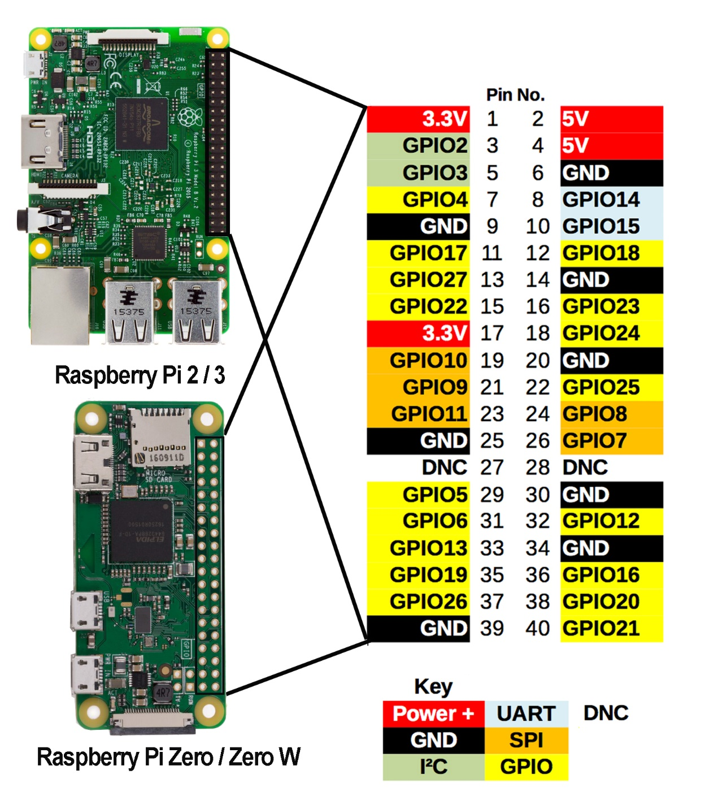

Above is a map of a Raspberry Pi and its GPIO pins. Power monitoring is set up for GPIO 13, which is pin 33. Water monitoring is set up for GPIO 17, which is pin 11.

**Power Monitoring:**

Power monitoring is done in two steps. It is looking for a loss of power, and then looking for a restoration of power. Both steps trigger an alert letting you know if the power is out or not. This is done just by monitoring DC voltage fed to pin 33/GPIO 13. Remember to use the convertor as shown at the beginning of this manual, as GPIO pins do not accept high voltage. GPIO pins take in DC voltage, and normal line voltage is AC.

**Water Monitoring:** Water monitoring is looking for a voltage. Thus, you should connect wire to a power line such as pin 1 or pin 2, and route it to the floor. Then, you should connect wire to pin 11/GPIO 17 and route it inches away from the previous wire. Since water is an electrical conductor, when water submerges the two wires, it will complete the circuit and trigger a water alert.

**Connection:**

You must decide where exactly you want to connect the Pi. One suggestion is that it can be a power cable plugged into an outlet which is stepped down and spliced to be connected to the GPIO pins. If you did not understand what the previous sentence said, then it is probably a good idea not to implement this project. As said many times throughout this manual, remember that power line work is extremely dangerous, so be very careful. Unless you have experience with live wires, please do not attempt to implement this project.